**Assignment 1**

1. What is JDK? JRE? JVM?

Jdk is the java development kit

Jre is Java runtime environment

Jvm is java virtual machine

1. What is java compiler?

Java compiler is a program that takes the text work of a developer and compiles it to a platform-independent java file.

1. Why is java platform independent?

Program compiles into byte code and byte code is platform independent

1. What is IDE? Why is it important for developers?

IDE is integrated development environment. It enables programmers to consolidates different aspects of writing a computer program.

1. Is java case sensitive?

Yes

1. What do the following key words do?  
   static: class-wide visible, final: can’t be changed, public: visible everywhere, private:visible only in this class, void: return nothing, null: null value, package: visible in this package, Class: a group of function, new: new object
2. What is primitive type and reference type?

Primitive type: int, char, long, double , float, short, byte, Boolean

Reference type: the other

1. Is parameter passed by value or reference?

By value

1. What is the output: System.out.println(1 > 0 : “A”:”B”);

A

1. How to define constants in java?

final

1. What is String? Is it primitive type?

String is a sequence of char, No

1. How to check if a String is representing a number?

Use Integer,parseInt()

1. Write a program to implement the following activity diagram:

Scanner s = new Scanner(System.in);

String str = s.nextLine();

try {

if (s.equals(‘q’)){

System.quit();

}

int x = Integer.parseInt(str);

if (x > 0) {

int sum = 0;

for (int i = 1; i <=x; i++) {

sum = sum + i;

}

for (int i = 1; i <=x; i++) {

System.out.println(sum);

}

} else {

throw new Exception(“Error”);

}

} catch (Exception e) {

log.info(“not an int”);

}

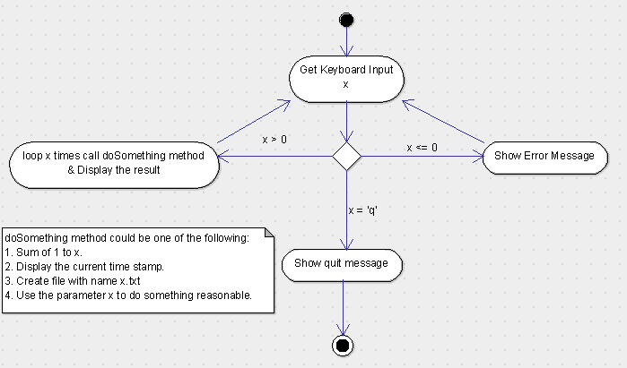

1. Write a program to merge two array of int.

Int a[] = …;

Int b[] = …;

int result = new int[a.length + b.length];

System.arraycopy(a,0,result,0,a.length);

System.arraycopy(b,0,result,a.length,b.length);

1. Write a program to find the second largest number inside an array of int.

int I,first second;

Arrays.sort(arr);

If( arr.length > 2){

Return arr[arr.length-1];

}else{ return arr[0];}